COMPETITIVE INTELLIGENCE & PRICING STRATEGY ENGINE FOR E-COMMERCE

WEEK 3 REPORT: COMPETITIVE LANDSCAPE MAPPING

Internship Program

Aarivya Labs Internship Program – H & P Projects

Domain
Data Analytics

Project Title
Competitive Intelligence & Pricing Strategy Engine for E-Commerce

Intern Name:Srijoswin Mazumder

Reporting Period:3rdWeek

- Introduction

Following the successful development of the data collection and web scraping process in Week 2, Week 3 aimed at transforming the raw collected data into a well-structured one that is ready to use for analytics. The raw collected data from Amazon, Flipkart, and Croma had several issues ranging from missing values, duplicate records, inconsistent rating system, among others.The main goal for this week was to enhance the quality of the data through cleaning, data standardization, exploration, and gaining business insight from competitor pricing.

This module serves as the basis for the other analytical modules to come including competitor positioning and pricing engine.

- Objectives of Week 3

Some of the major objectives in Week 3 include:
- Cleaning and preprocessing of collected data.
- Handling missing and inconsistent values.
- Standardizing of variables both categorical and numerical.
- Normalizing of pricing-related information.
- Develop data quality assessment framework.
- Conduct exploratory data analysis.
- Business insights from the competitor pricing information.
- Developing visualizations for informed strategic decisions.

3. Dataset Description

The dataset utilized at this stage is the master dataset created in Week 2.

The dataset consisted of product details from:
- Amazon
- Flipkart
- Croma

Available attributes include:

- Timestamp
- Platform
- Brand
- Product Name
- Current Price
- Original Price
- Discount %.
- Rating
- Review Count
- Product URL

Multiple products from various brands and their competitors were available in the dataset, serving as an excellent basis for comparative analysis.

4. Data Cleaning Process

As part of the first step, we aimed at addressing any data quality problems identified.
Some of the data quality challenges faced during this process include:
- Lack of rating and review details.
- Differing ways of naming brands in the dataset.
- Duplicates arising from multiple scraping session.
- Multiple ways of storing ratings including:
- 4.2
- 4.1 out of 5
- 3.8 stars
- Lack of original price information in some cases.

Cleaning steps included:

Duplicates Elimination
Detection and removal of duplicates to ensure that only unique entries remain.

Brand Uniformity
Conversion of brands into one consistent way of writing to ensure no duplication within brands.

Examples include:
boat → Boat
BOAT → Boat
boAt → Boat

Standardizing Ratings
Regular expression was used to convert ratings in text format into numeric format.

Examples:
“4.3 out of 5” = 4.3
“4.1 stars” = 4.1

Handling Missing Data
- The missing values were handled as follows:
- The missing ratings were filled by using median ratings.
- The missing number of reviews was filled by using “0”.
- The missing discount percentages were filled by using “0”.
- The missing price tags were filled by using current price tags.

Conversion to Numerical Values
All columns related to price, discount, rating, and reviews were converted to numerical values.

5. Price Normalization

Following data cleansing, pricing was normalized to ensure accurate comparability of prices among different platforms.

Additional calculations were conducted:

Price Difference
Price Difference = Original Price - Current Price
This measure represents the absolute saving of money made by consumers.

Savings Percentage
Savings Percentage = (Price Difference / Original Price) x 100
This measure allows comparison of savings across items irrespective of their prices.

Effective Price
In the case of the current analysis, effective price was equal to current price owing to lack of shipping cost and loyalty discount details.
These measures serve as a basis for further modeling of pricing strategies.

- Data Quality Assessment

A data quality scorecard was created to test the quality of the dataset.
The scorecard included assessments on:
- Amount of missing values per column.
- Level of data completeness (percentage).
- Presence of necessary characteristics.
- Consistency between platforms.

It was determined that the cleansed dataset had higher quality than the original one and was ready for further analysis.\

7. Exploratory Data Analysis (EDA)

The Exploratory Data Analysis was carried out in order to get insights into the pricing patterns, discounting strategies, and customer interactions of the competitors.

Various visualizations were made in an effort to find patterns and opportunities.
Key areas analyzed were:
- Pricing pattern by platform.
- Pricing comparisons by brand.
- Discounting pattern.
- Relationship between rating and price.
- Consumer review patterns.

8. Platform-Based Pricing Analysis

A comparison study was done using the three main platforms i.e. Amazon, Flipkart, and Croma.

The key things that had to be identified were:
- Pricing level in general.
- Premium vs budget positioning.
- Competitiveness among platforms.

It can be observed from the data analysis that different platforms have used different pricing strategies.

While Croma had adopted a more premium-based approach towards electronics-based products, the other two platforms exhibited more competitiveness through pricing and discounting.

9. Brand-wise Analysis

Analysis on the level of branding was made based on product pricing averages.
It was established:
- Presence of premium brands characterized by high average selling prices;
- Existence of affordable brands;
- Consistent product pricing across several platforms.
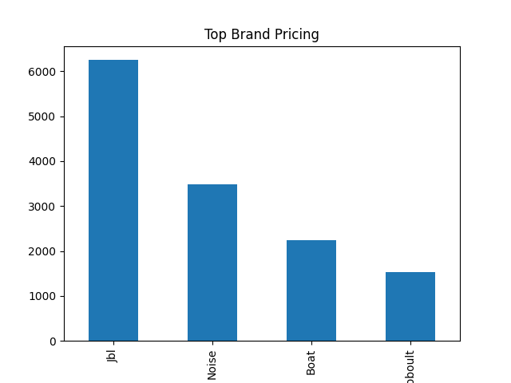

From the analysis conducted, it is clear that powerful brands can sell their products at high prices even in the presence of discounts.

10. Discount Analysis

Percentages of discounts were analyzed across various platforms.
This was done to establish marketing strategies employed by other companies.

Some of the findings were:
- Discounting of products frequently by marketplace-driven platforms;
- Limited discounting by premium retailers; and
- Categories of products in which heavy discounts are offered.
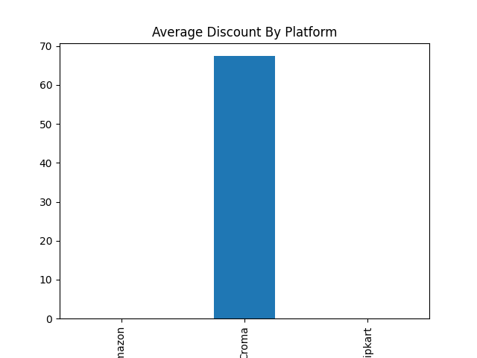
Discounter analysis is important in formulating future pricing and marketing strategies.

11. The Relationship between Rating and Price

Scatter Plot is used to understand the relationship between the rating of the products and prices.
The main goal was to establish if expensive products will consistently have higher ratings.

It turns out that:
- Expensive products don’t always have higher ratings.
- Mid-level products can receive high ratings compared to premium products.
- Customer satisfaction is dependent on several elements other than prices.

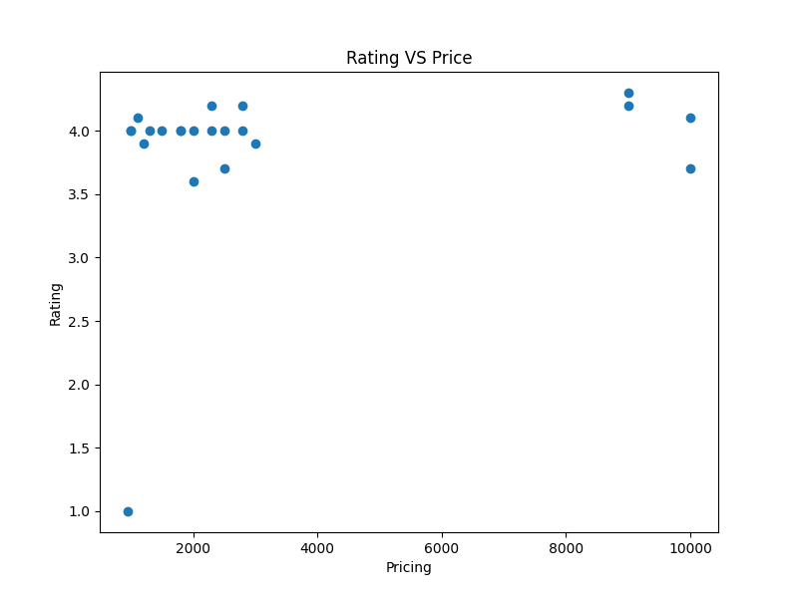

The above information could be used by firms to select products that have better value propositions.

12. Competitive Intelligence Information Gathered

Using the gathered data, the following strategic insights have been identified.
Insights on Pricing Strategy
- Amazon focuses on credibility and trust.
- Flipkart usually relies on discounts for pricing.
- Croma sells itself as a premium electronics store.

Insights on Customer Behavior
- Discounts attract more customer attention.
- Products with high reviews have high visibility and trust levels.

Insights on Market Opportunities
- There is disparity in prices across certain products.
- Market opportunities for dynamic repricing strategies are available.
- Low-priced competitors in certain products could be used as an entry point.

The above information is useful for building an intelligent pricing system.

13. Business Recommendations

The analysis performed in Week 3 resulted in the following business recommendations:

Recommendation 1
Keep track of competitors' discounts and change prices dynamically if substantial differences in price are observed.

Recommendation 2
Pay attention to those products that have highly-rated reviews but reasonable prices because they create high value for consumers.

Recommendation 3
Establish automated notifications regarding price fluctuations of main competitors.

Recommendation 4
Apply previous pricing data in order to establish patterns for promotions.

Recommendation 5
Focus on products having high levels of customer interaction due to their profit-creating potential.

14. Challenges Faced

There are several challenges related to technology and analysis faced during Week 3.

Challenge 1
Data about ratings was provided in various forms and required intensive cleaning.

Challenge 2
Missing values lowered the level of dataset uniformity and required imputing missing data.

Challenge 3
Specific data structures for each platform complicated the process of standardization.

Challenge 4
Problems with storing file paths and charts occurred.

Challenge 5
Diverse types of prices and discounts required data pre-processing before analysis.

15. Outputs Produced

The following outputs have been produced:
- Cleaned Dataset
- Normalized Dataset
- Data Quality Scorecard
- Price Distribution on Platforms Graph
- Discount Analysis Graph
- Brand Comparisons Graphs
- Relationship between Rating and Price Graphs
- Business Insights Report
- Competitive Intelligence Report

16. Conclusion

In Week 3, the raw data of competitors has been converted into an analytics-friendly dataset. The process of data cleaning, normalization, assessing quality, and performing exploratory analysis made the collected information much more reliable compared to the state at the end of Week 2.

The produced insights provided valuable information about competitors' pricing practices, discounting policies, and approaches to engaging customers. It is safe to say that we have reached a solid analytical base for the subsequent stages of our project.

We have cleaned the dataset, performed competitive intelligence analysis, and are now ready to continue working on the following week's assignments such as positioning, opportunities analysis, perceptual maps, and pricing gaps.

